Assignment

Programming in Java – Assignment 1, part 1, Summer series 2005

Index

Source Code 2
Date.java 2
TestDate.java 5
Results 10
1. Validation 10
2. Options 11
2.1. Show date in extended format and the following date 11
2.2 daysUntil 12
2.3 Calendar 13
2.4. Unexpected behavoir 14
Considerations 16
Javadoc main

~~~

The Source Code

1. Date.java

/**
* File Date.java
*Author André Baumann
* --Assignment 1a--

*Description:
* - Defines class with methods for a Date object.
* - Uses constructor methods, methods, get and set methods.
*/

class Date {

//var for day, month, year

private int d, m, y;
int weekday;
int sfx;
int mth;
int diff;
int i;

//default constructors, the Date OBJECT, setting initial value

public Date(int dd, int mm, int yy) {

d = dd;
m = mm;
y = yy;
}

public Date() { d = 0; m = 0; y = 0;}

public Date(Date date) {

d = date.d;
m = date.m;
y = date.y;
}

//access, mutation methods

public int getDay() {return d;}
public int getMonth() {return m;}
public int getYear() {return y;}

public void setDay(int dd) {d = dd;}
public void setMonth(int mm) {m = mm;}
public void setYear(int yy) {y = yy;}

/**
*methods
*/

//Suffix method (OK)

public int Suffix() {

if (d == 1 || d == 21 || d == 31)
sfx = 0;

if (d == 2 || d == 22)
sfx = 1;

if (d == 3 || d == 23)
sfx = 2;

if (d >= 4 && d <=20 || d >= 24 && d <= 30)
sfx = 3;

return sfx;

} //end Suffix

//Zeller method (OK)

public int Zeller() {

//is parse necessary or does Math.floor do it for me?
weekday = ((int)(y + Math.floor(y / 4) - Math.floor(y / 100) + Math.floor (y / 400) + Math.floor(2.6 * m + 1.6) + d)) % 7;

return weekday;

} // end Zeller

//Tomorrow method (OK)
public void Tomorrow() {

//if end of a month is reached, adjust dd, mm, yy
if (m == 2 && d == 28 || m== 2 && d == 29 || m == 1 && d == 31 || m == 3 && d == 31 || m == 5 && d == 31 || m == 7 && d == 31 || m == 8 && d == 31 || m == 10 && d == 31 || m == 4 && d == 30 || m == 6 && d == 30 || m == 9 && d == 30 || m == 11 && d == 30)

{
d = 1;
m = m + 1;
y = y;
}
else
{
d = d + 1;
m = m;
y = y;
}

//if end of year is reached, adjust dd, mm, yy to New Year

if (m == 12 && d == 31)

{
d = 1;
m = 1;
y = y + 1;
}

return;

} // end Tomorrow

//toString method (OK)
public String toString() {

String[] dayofweek = {"Sunday", "Monday", "Tuesday", "Wednesday", "Thursday", "Friday", "Saturday"};

String[] daysuffix = {"st", "nd", "rd", "th"};

String[] Mon = {"January", "February", "March", "April", "May", "June","July","August","September","October","November","December"};

String LongFormat = dayofweek[weekday]+", "+d+daysuffix[sfx]+" of "+Mon[m-1]+" "+y+"\n\n";

return LongFormat;

} // end toString

//daysUntil method (working on..)
public int daysUntil() {

int c_day = d;
int c_month, c_year;
int diff = 0;
int i_d = 0, i_m = 0;

int [] mymonth = {31,28,31,30,31,30,31,31,30,31,30,31};

for (i_m = m-1; i_m < mymonth.length; i_m++) {

if(i_m > m-1) c_day=1;

for (i_d = c_day; i_d <= mymonth[i_m]; i_d++) {
diff++;
}
}
return diff;

} // end daysUntil

} //end class date
2. Date.java

/*
File TestDate.java
Author André Baumann
--Assignment 1a--

Description:
-Tests the Date.class
-Provides valid input
*/

import java.io.*;
import corejava.*;

public class TestDate
{
public static void main(String args[]) throws IOException
{

int day, month, year;

int leapyear = 0;
int weekday, sfx;

boolean valid = true;
boolean menuvalid = true;
boolean loop = true;

Date doom;
Date endofyear;
Date cal;

String longformat;

char op, go;

do
{
System.out.println("\n============= START =======================================");

BufferedReader br = new BufferedReader(new InputStreamReader(System.in));

/**
*Start of Data input: 3 do - while loops for year, month and day and
*validate that date
*/

//check year

do
{
valid = true;
year = Console.readInt("\n Enter year 'YYYY' >");

if (year < 1582)
System.out.println("\n !Invalid year! Year should be >= 1582.");

else valid = false;
}

while (valid);

//check leapyear

if (year%4 == 0)
{
if (year%100 == 0)
{
if (year%400 ==0) leapyear = 1;
else leapyear = 0;
}
else leapyear = 1;

}
System.out.println("help:leapyear " +leapyear);

do
{ valid = true;

//check month

month = Console.readInt("\nEnter month 'MM':");
if (month <= 0 || month > 12)
System.out.println("\n!Invalid month! Month can be 1..12.");

else valid = false;
}
while (valid);

//check day

do
{ valid = true;

day = Console.readInt("\nEnter day 'DD':");

if (day < 1 || day > 31 || (day > 30 && month == 4) || (day > 30 && month == 6) || (day > 30 && month == 9) || (day > 30 && month == 11))

System.out.println("\n!invalid number of days!");

else if (day > 28 && month == 2)
{
if ((leapyear == 0 && day > 28) || (leapyear == 1 && day > 29))
System.out.println("\n!Impossible date in February!");
else valid = false;
}

else valid = false;
}
while (valid);

System.out.println("\n---Valid---");

//end of validation

/**
*Creates a new instance on the object, based on validation process
*/
doom = new Date();
doom.setDay(day);
doom.setMonth(month);
doom.setYear(year);

/**
*Program now presents a menu, its options are called through a switch
*/
do
{
String menu = Console.readLine("\n\n============= MENU ========================================\n\n1. Show the given date in extended Format\n2. Show date after a given date\n3. Find number of days left in a year\n4. Show the calender for a month\n5. Quit\n");

op = menu.charAt(0);

switch (op)
{

case '1':

//calculates weekday calling Zeller method
weekday = doom.Zeller();

//calculates the daysuffix calling Suffix
sfx = doom.Suffix();

//System.out.println("help:weekday " +weekday);
System.out.println("\nDate in extended Format :\n");

//calls the toString method on instance doom and returns result:
longformat = doom.toString();

// print the date in long format calling the toString method
System.out.println(longformat.toString());

break;

case '2':

//puts doom through Tomorrow to add one day
doom.Tomorrow();

weekday = doom.Zeller();
sfx = doom.Suffix();

//calls the toString method with this instance
System.out.println("\nThe following day is :\n");
longformat = doom.toString();
System.out.println(longformat.toString());

break;

case '3':

//calling daysUntil method to calculate days between

endofyear = new Date();
endofyear.setDay(31);
endofyear.setMonth(12);
endofyear.setYear(2004);

int diffday = doom.daysUntil();
//doom.daysUntil(endofyear);

System.out.println("\nFrom the given date until 31-12 of that year there are "+diffday+" days left\n\n");
break;

case '4':

// create a Calendar

cal = new Date();
cal.setDay(1);
cal.setMonth(month);
cal.setYear(year);

//calculates weekday 1 of the month calling Zeller()
weekday = cal.Zeller();

String[] Mon = {"January","February","March","April","May","June","July","August","September","October","November","December"};

// print the Calendar Header
System.out.println("\n\n========= CALENDAR VIEW ====================================\n");
System.out.println(" "+Mon[month-1]+" "+year+"\n");
System.out.println("\tSun \tMon \tTue \tWed \tThu \tFri \tSat");

int [] mlenght = {31,28,31,30,31,30,31,31,30,31,30,31};
int days_month = mlenght[month-1];

// Counters, with i_day to 1 which is first day of the given month
int i_day = 1;
int i_horizontal;
int i_vertical;

// Count downwards (needs possibly 6 rows)
for(i_vertical = 0; i_vertical < 6; i_vertical++)
{
// Also count sidewards (7 weekdays)
for (i_horizontal = 0; i_horizontal < 7; i_horizontal++)
{

if ((i_horizontal < weekday) & (i_vertical == 0))

System.out.print("\t");

else
{
if (i_day <= days_month)
{
//print what is calculated so far
System.out.print("\t"+i_day);
i_day++;
}
} //close else

} //close horizontal count

//continues print in a new line
System.out.println();

} //close vertical count

System.out.println("\n==========================================================");

break;

case '5':

//exit menu and quit program

String again = Console.readLine("Sure? y/n");
go = again.charAt(0);
if (go == 'y' || go == 'Y')
{
loop = false;
System.exit(0);
}
break;

default:
System.out.println("\nInvalid comand\n");

} //end switch

} while (op != 5); //display menu until 5 was entered

} while(loop); //end of do while loop

} //ends main

} //end testdate

Results
1. Validation

Figure 1 .. 3 show the output the user sees first. A valid input is required in order to proceed to the menu.
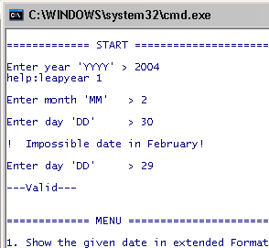
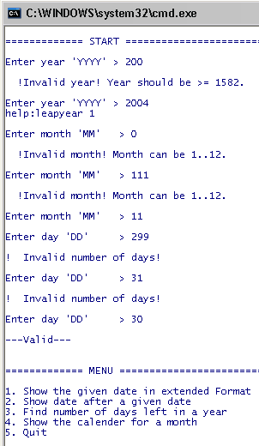
Fig. 3
Fig. 1

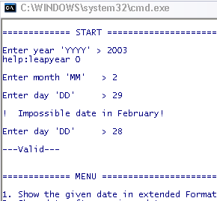
Fig. 2

2. Options
2.1. Show date in extended format and the following date
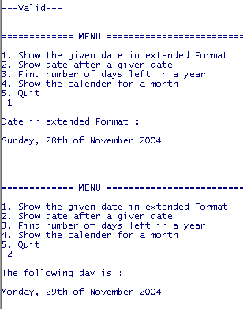
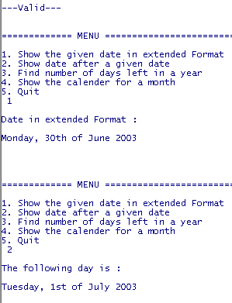
Fig. 4
Fig. 6

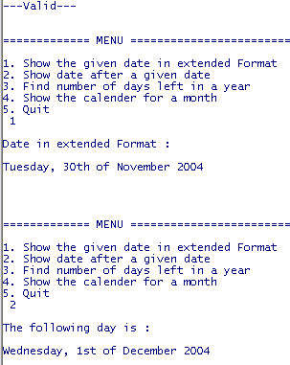
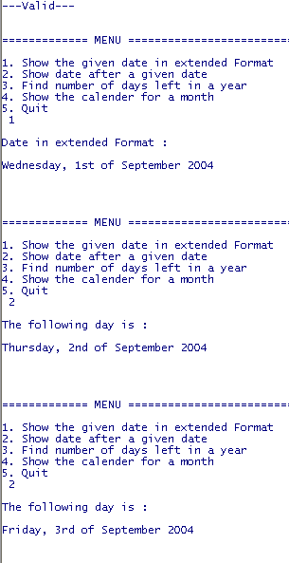
Fig. 5
Fig. 7

2.2. daysUntil

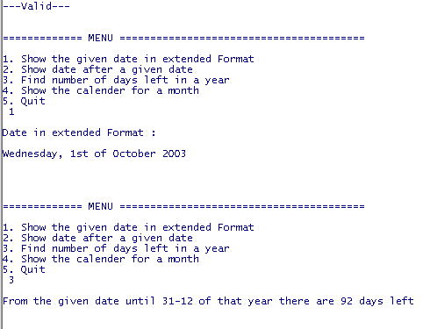
Fig. 8

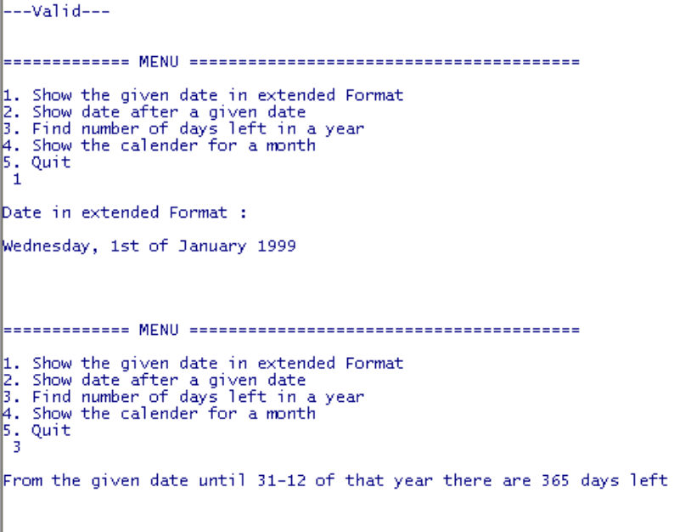
Fig. 9

2. 3 Calendar
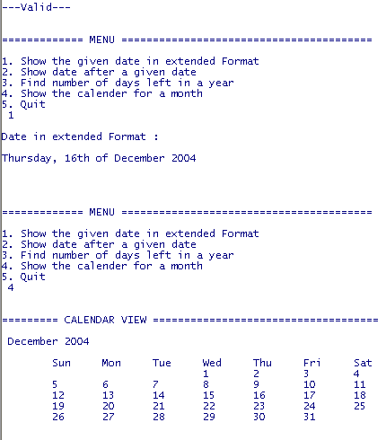
Fig. 10

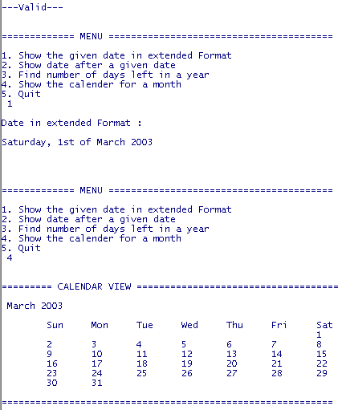
Fig. 11

2. 4 Unexpected behaviour:
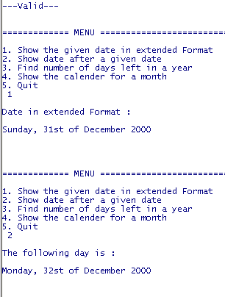
Fig. 12

Program does not count++ the month and the year

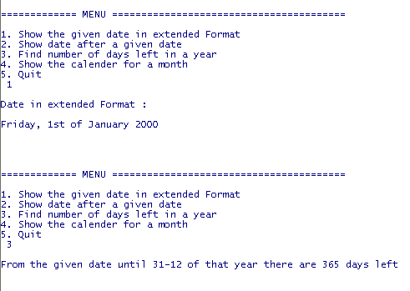
Fig. 13

(leapyear should have 366 days)

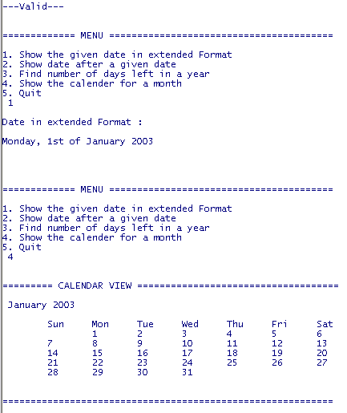
Fig. 14

(1st of Jan 2003 was Wed)

Considerations

The validation, to be found in the TestDate.class should have been placed in the Date class. However, difficulties with the BufferedReader left no better other option in order to keep the program running.

Testdate.java

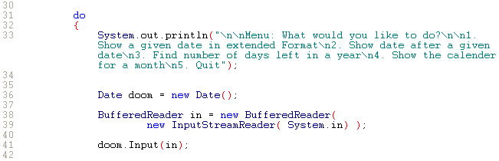

Date.java

